School of Computer Engineering, KIIT Deemed to be University
Computer Networks Laboratory (CS39003)
Lab Assignment
Packet Analysis using Wireshark: Protocols, Ping and Traceroute
Name | Arkadeep Mondal | Roll No. | 2405036
Section / Group | CS22 | Date of Lab | 24/9/2026
Full Marks | 10 | Due Date

Objective
Capture your own traffic with Wireshark, identify the protocols involved, follow an HTTP exchange, then study the ICMP echo request/reply exchange behind ping and the TTL-based hop discovery behind traceroute, reading the details straight from the captured IP and ICMP headers.
Ground rules
- Every answer must come from your own captures. Quote frame numbers so your answers can be checked against your .pcapng files.
- Capture on the interface that carries your Internet traffic (Wi-Fi or Ethernet). Close browsers and downloads before the ping and traceroute captures.
- Run ping and traceroute in a Linux or macOS terminal (or a Linux VM in bridged mode). Windows: ping -n 5 www.kiit.ac.in and tracert www.kiit.ac.in.
- If www.kiit.ac.in does not reply on your network, substitute another reachable site (e.g. your institution's own domain) in both commands, and note which host you used.
- Identical captures or answer sheets will be treated as copying, and all involved will lose the marks.

Marks distribution
Part | Topic | Marks | Awarded
A | Getting started: protocols and HTTP GET / OK | 2
B | Ping and the ICMP echo request/reply exchange | 4
C | Traceroute and IP header fields | 3
D | Evidence and presentation | 1
 | Total | 10

Part A: Getting Started with Wireshark (2 marks)
Task A. Start Wireshark capturing on your active interface. While it runs, open http://neverssl.com in a browser (it never redirects to HTTPS, so the HTTP exchange is easy to capture). Stop the capture and save it as RollNo_intro.pcapng.
A1. In the unfiltered packet list, name three different protocols from the Protocol column and say in one line what each was doing. [0.5]
DNS: Trying to get the IP address for the given domain name
NTP:Sync the clocks between the server and my client computer
ARP: ask the mac address of a local ip , as in which device has been assigned a certain ip

A2. Apply the filter http. Find the GET request and the 200 OK reply. Give
(i) both frame numbers, and each packet's value in Wireshark's Time column (seconds since capture start, as shown, to at least 3 decimal places); then state the reply time minus the request time as the elapsed time;

GET- frame no 110 , time - 12.373
Reply OK- frame no 123 , time - 12.695
Elapsed Time: 0.322 sec

(ii) the IP address of neverssl.com and of your computer, read from the IP layer of the GET frame;
Local Ip : 172.19.165.17
Ip of neverssl : 32.223.124.45

(iii) a screenshot of the GET packet with Frame, Ethernet, IP and TCP collapsed and HTTP expanded. [1.5]
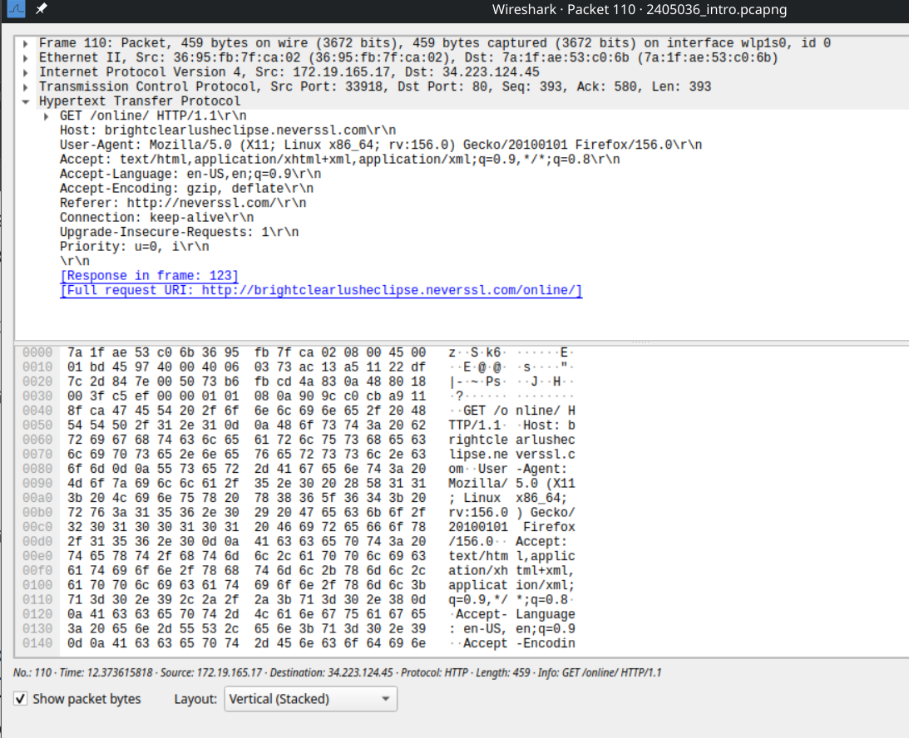

Part B: Ping and the ICMP Echo Exchange (4 marks)
Task B. Start a new capture, run the command below, then stop and save as RollNo_ping.pcapng.
ping -c 5 www.kiit.ac.in

B1. How many ICMP packets were exchanged in total? Give the filter you used, and split the count into requests sent and replies received. What ICMP type and code does a request use, and what type and code does a reply use? [1]
Ans:
ICMP Packets sent = 5 Packets
ICMP Packets Recieved = 5Packets
Total 10 Packets
Filter Used : ICMPv6

ICMP Request:
Type: Echo ping request 128
Code : 0
ICMP REPLY:
Type: Echo ping reply 129
Code : 0
B2. Complete Table B-1 for all five pings. [2]
B3. In 4 to 6 lines, explain:
(a) how Wireshark (or ping) matches each reply to its request, given that several requests are in flight using the same protocol;

The ping replies are properly matched using the id and seq number fields in the ICMP header
Here the id is 0xdc3d and the sequence number goes from 1- 5

(b) why the Identification field differs between consecutive requests;
The id remains same but the seq field increases by 1 on each consecutive ping request ,this is done to properly match the reply packet with its request packet

(c) what the round-trip time tells you, and why it might vary between the five pings. [1]

The RTT time tells us about the latency between sending and receiving a packet. RTT varies across different pings as there are variations in network congestion , delays etc in between the intermediate routers, switches and the target server.
Table B-1: Ping requests and replies
Seq | Request frame no. | Request Time column value | Request TTL | Reply frame no. | Reply Time column value | Round-trip time (reply time − request time)
1 | 5 | 0.064903901 | 64 | 6 | 0.108230856 | 0.043326955
2 | 9 | 1.066308462 | 64 | 10 | 1.122897027 | 0.056588565
3 | 11 | 2.068234305 | 64 | 12 | 2.127985741 | 0.059751436
4 | 13 | 3.070510425 | 64 | 14 | 3.116122800 | 0.045612375
5 | 15 | 4.072765085 | 64 | 16 | 4.129446682 | 0.056681597
"Time column value" is the figure shown in Wireshark's Time column for that frame (seconds since capture start, as displayed, to at least 3 decimal places) - do not convert it to a clock time. Write "no reply" if a request got none.

Part C: Traceroute and IP Header Fields (3 marks)
Task C. Start a new capture, run the command below, then stop and save as RollNo_traceroute.pcapng. Keep the terminal output.
traceroute -q 5 www.kiit.ac.in

C1. How many hops did the traceroute show, and did it reach the destination or end in * lines? How many packets were sent by your client in total, and how many replies came back? Fill Table C-1 (one row per router or server, plus the client row). Attach a screenshot of the terminal output. [1.5]
Number of hops: 30 hops
No it did not reach the final destination and ended in *** , some firewall blocked or dropped the UDP probe packets
Packets Sent: 150(30 X 5 probes due to –q 5)
Packets received : 10 (5 from hop 1 and 5 from hop 2)

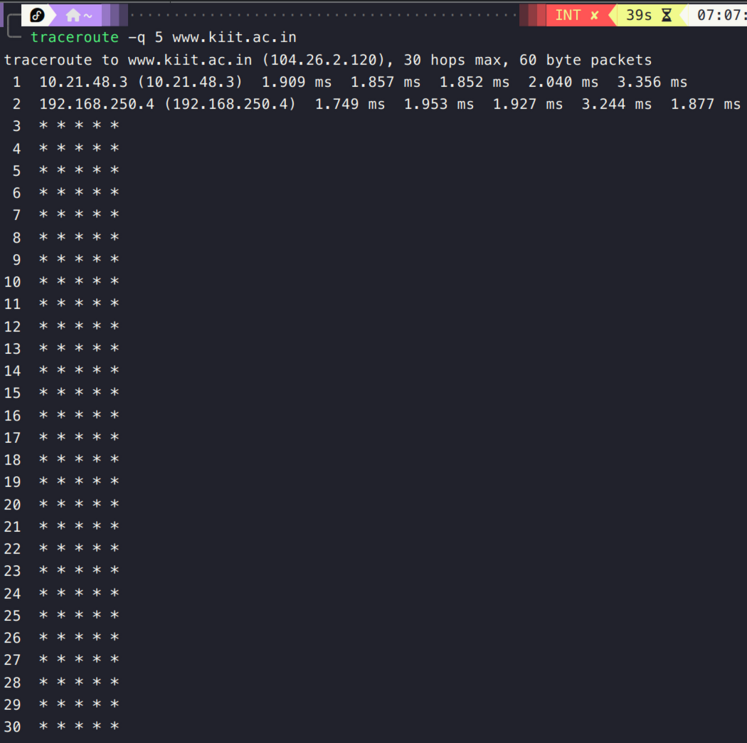
C2. Across the probes your client sent, classify each IP header field below as constant or changing, and explain in one line why the protocol requires (or merely happens to produce) that behaviour. Fill Table C-2. [1.5]
Table C-1: Packet count per node
Hop | Router / server IP | Probes sent to this node | Replies received from this node | ICMP type of reply (if any)
1 | 10.21.48.3 | 5 | 5 | Type: Time-to-live exceeded (11)
2 | 192.168.250.4 | 5 | 5 | Type: Time-to-live exceeded (11)
3 | No reply (* * * * *) | 5 | 0 | None( Timeout)
4 | No reply (* * * * *) | 5 | 0 | None( Timeout)
5-30 | No reply (* * * * *) | 130 | 0 | None( Timeout)
Client | Your host (totals) | 150 | 10
Table C-2: IP header fields across the traceroute probes
Field | Constant or changes? | Reason (one line: why the protocol requires or merely produces this)
Version | Constant | All outgoing probes exclusively use IPv4 (version 4) throughout the trace.
Total length | Constant | Each probe packet maintains a fixed total payload and header length (60 bytes).
Identification | Changes | The OS IP stack increments packet Identification to uniquely label each outgoing packet.
Time to live | Changes | Traceroute intentionally increments TTL by 1 after every set of 5 probes to discover successive network hops.
Protocol | Constant | Standard Linux traceroute uses UDP (protocol number 17) for all outgoing probe packets.
Header checksum | Changes | Changing header fields like TTL and Identification means we have to recalculate the IP checksum
Source and destination address | Constant | All probes originate from local client IP (10.21.60.132) and target the same destination IP (104.26.2.120)

Part D: Evidence and Presentation (1 mark)
Submit the following as instructed by your lab instructor.
✓ | Item | Marks
 | Three capture files RollNo_intro.pcapng, RollNo_ping.pcapng, RollNo_traceroute.pcapng, all opening correctly in Wireshark | 0.5
 | One PDF report RollNo_CN_Lab.pdf with answers, tables and screenshots. Screenshots show frame numbers and the Time column and are labelled with the question number | 0.5

